1- ALL LOGIC GATES USING NAND GATE.

- NOT gate using NAND gate

2) AND gate using NAND gate

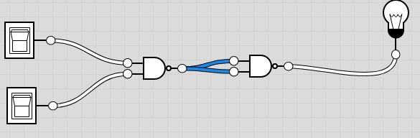
3) OR gate using NAND gate


4) NOR gate using NAND gate


5 ) XOR gate using NAND gate


6) XNOR gate using NAND gate
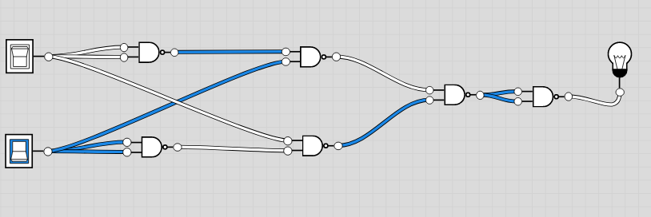

2- ALL LOGIC GATES USING NOR GATE

1) NOT gate using NOR gate
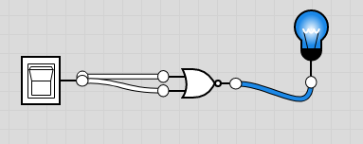

2) OR gate using NOR gate
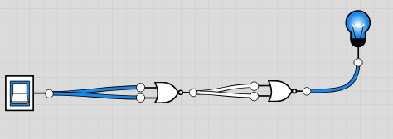

3) AND gate using NOR gate

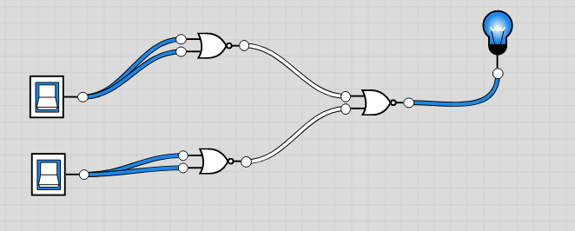
4) NAND gate using NOR gate

5) XNOR gate using NOR gate
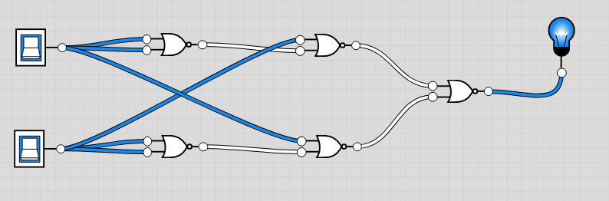
6) XOR gate using NOR gate



TASK-3
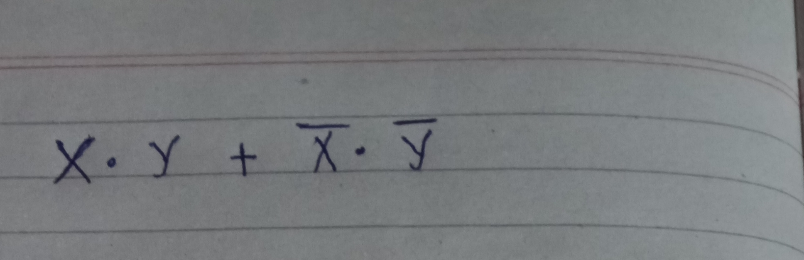

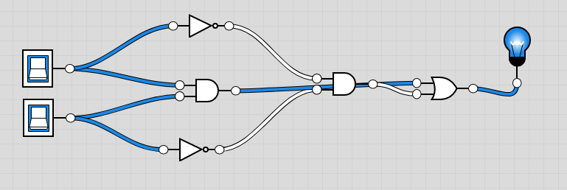

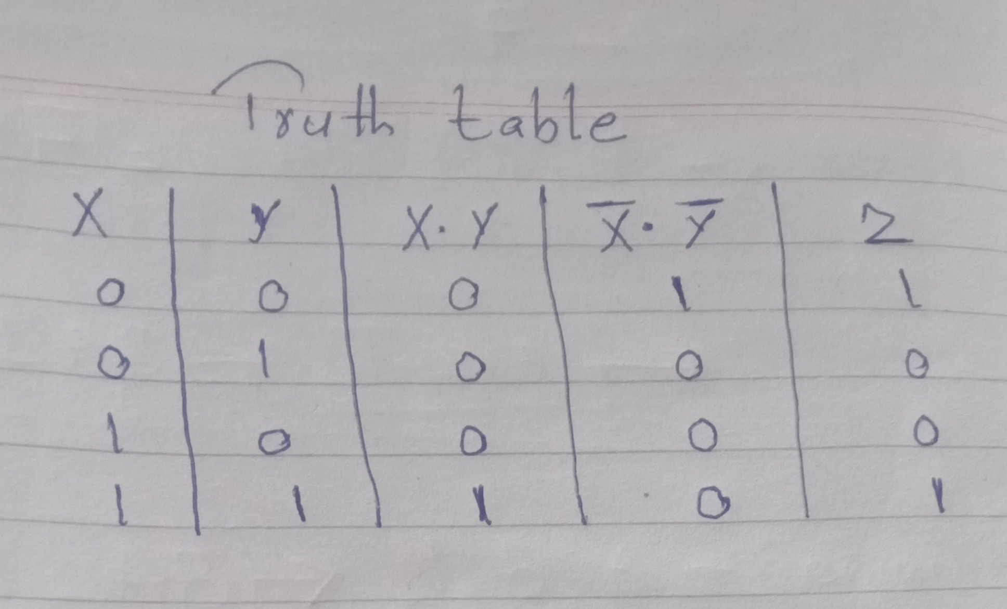

TASK-4

